阿INSTRUCTION MANUAL
USER MANUAL OF WiFi SOCKET
MODEL NO.: 8WD-IWSS001

Afterles Support - Help Desk

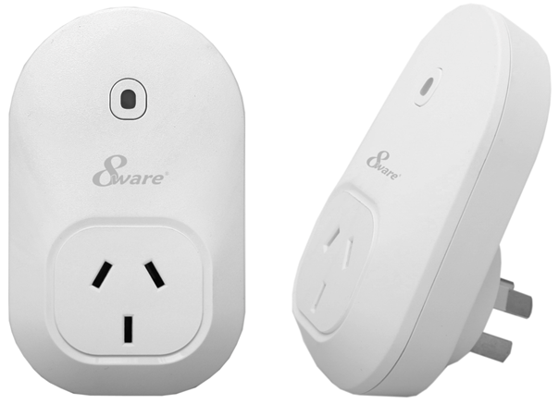

Contents

General Safety Instructions.....................3
Product Features.....................................4
Parts List / Technical Specifications.........5
Product Setup..........................................6
Product Operation...................................15
Timers & Schedules................................17
FAQ’S ....................................................25

General Safety Instructions
Read this manual thoroughly before first use and keep it in a safe place for
future reference, along with the purchase receipt and carton.
The safety precautions enclosed herein reduce the risk of fire, electric shock
and injury when correctly adhered to. Follow all instructions and take notice
of all warnings to reduce the risk of fire or electric shock.
• Indoor use only
• Do not exceed the maximum power rating 10A or 2400W
• Do not expose to water, dust, chemicals and moisture
• Keep away from heat sources and direct sunlight
• Children and infirm persons should use this device only under the
supervision of a responsible adult to control appliances safely
• Young children must be supervised to ensure they do not play with
this device.
• Do not operate or control heat producing devices connected to the
Wifi socket when unattended.
• Do not drop or subject the device to undue shock
• Unplug this device during lightning storms or when unused for long
periods of time

Product Features
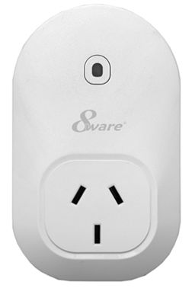
LED indicator/
Operating button →

- Control the Wifi Socket from anywhere, using your iOS/ Android Device
- Check the current status of your Wifi Socket from anywhere, using your iOS / Android device
- Easy to setup on your existing wireless network
- Set timers to activate your according to a schedule
- Control up to 100 Wifi Sockets using one iOS / Android device
- Gives you extra control to conserve energy
* Wifi Socket requires a Wi-Fi network. Mobile remote control
requires an iOS or Android device with Wi-Fi, 3G or 4G connection.

After Sales Support - Help Desk

Parts List
• Wifi Socket
• Getting Started Guide
• Instruction Manual
Technical Specifications
Voltage: 240V AC 50HZ
Max load current: 10A
Total load must not exceed 2400W
Working temperature: 0-50°C
Network: 802.11, b/g/n
Security: WPA-PSK / WPA2-PSK / WPA / WPA2 / WEP / WPS2 / WAPI
Encryption Type: WEP / TKIP / AES

Product Setup
Before you can use your Wifi Socket, it must be set up using your
Android/iOS device.
Initial setup must be performed using your home Wi-Fi network.
Once it has been set up you can control your power outlet via Wi-Fi/3G/4G.
Important: A current mobile service plan is required for correct
operation over 3G & 4G. Mobile data may be required for some
features. The supplier is not responsible for any chargers incurred.
Please contact your network service provider for further information
about your current data plan and any associated charges.
Note: Consult your device’s instruction manual if you are unsure
how to download apps, connect to Wi-Fi or any other functions of
your Android or iOS device.
Software
The free SmartPoint App is available for Android and iPhone, and is required
to operate your Wifi Socket.
1. Ensure your iOS / Android device is connected to the internet using your
home Wi-Fi network.
2. Open the App store/Google Market on your phone.
3. Search for “SmartPoint” in the App store/ Google Market
4. Download the “SmartPoint” App to your phone.

Connecting the Wifi Socket to your Wi-Fi network
Initial setup must be performed using your home Wi-Fi network.
1. Ensure your iOS / Android device is connected to your home Wi-Fi
network. Refer to your device manual for further details on connecting
your device to Wi-Fi.
2. Open the SmartPoint App on your iOS / Android device
3. Click the settings icon at the bottom of the screen, then select Smart
Setup.

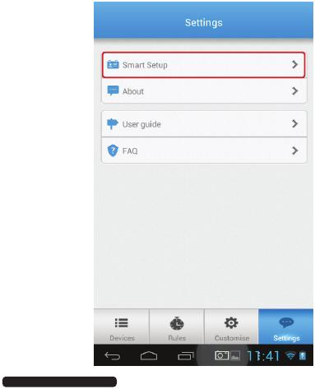

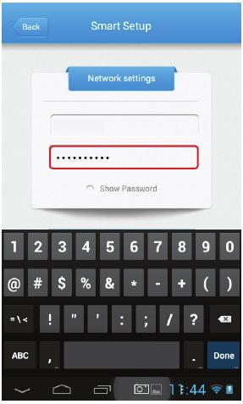

4.
Your wireless network name (SSID) is shown in the smart setup screen
below is an empty field to enter your Wi-Fi network password. Enter
your password into this box.

SSID

5.

Insert the Wifi Socket into the power socket. Turn on the power outlet.
The Wifi Socket will begin to blink red rapidly to indicate it has
entered pairing mode.If the LED does not blink rapidly in red ,
press the button for 5 secs and it should do so.

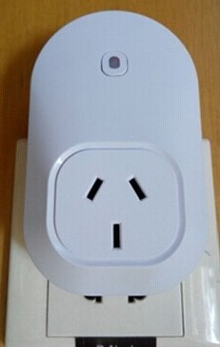

6.
7.
While the light is flashing rapidly, select the Setup New Socket button in
the SmartPoint App to begin the pairing process.
Once paired, you will see a ‘Config successful’ message. If you do not
see this message repeat step 5 or refer to the FAQ at the back of the
manual for more information.
Note: The configuration process should take about 1 minute or less.

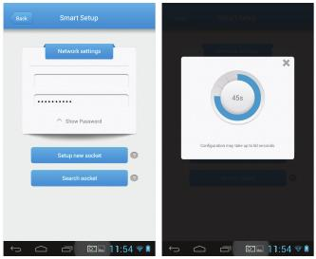
SSID

8.
Once configuration is complete, press Back, then press Devices. Press
the on-screen power button to check that your Wifi Socket is now operating.

9. Connect the appliance you wish to control to the socket of the Wifi Socket.

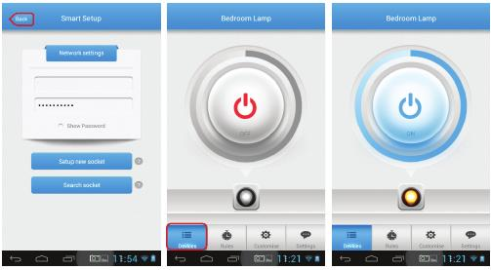

SSID

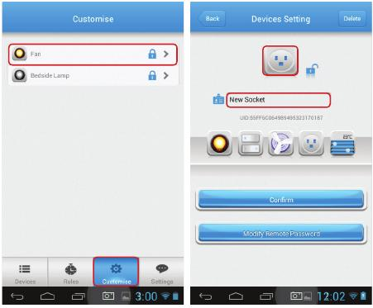
Customise your Wifi Socket
The Wifi Socket can be customised to allow you to easily tell the difference
between multiple plugs connected to your network.
1. Open the SmartPoint App, and select Customise from the main screen.
2. Select the Wifi Socket you wish to modify, and you will see the current
and current graphic icon displayed.

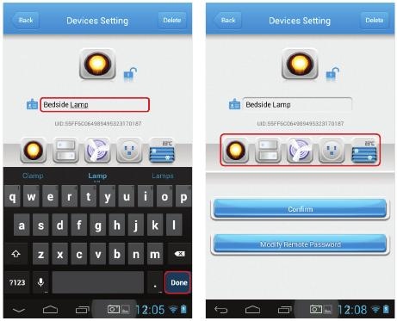

3.
4.
5.
To change the name of the Wifi Socket, click the name field,and modify
the text. When you have finished, press done.
Select the graphic you wish to be displayed for this Wifi Socket
by clicking on the icons.
Press Confirm to save your changes, and return to the Customise menu.

Locking your Wifi Socket
You can lock the Wifi Socket to prevent new users from discovering
the Wifi Socket over your local network.
1. Open the SmartPoint App, and select Customise from the main screen.
2. Select the Wifi Socket you wish to modify, and you will
see the current name and current graphic icon displayed.
3. Press the lock icon to lock the Wifi Socket from being
discovered by new users.

Changing your password
Once you have set up your Wifi Socket, you can add a password
to prevent other users accessing the device remotely.
1. Open the SmartPoint App, and select Customise from the main screen.
2. Select the Wifi Socket you wish to modify, and you will
see the current name and current graphic icon displayed.
3. Select Modify Remote Password to set a password for the Wifi socket.
4. Enter the old password, and your new password, then press OK.
Note: The default password is 888888.
5. Press Confirm to save your changes, and return to the Customise menu.

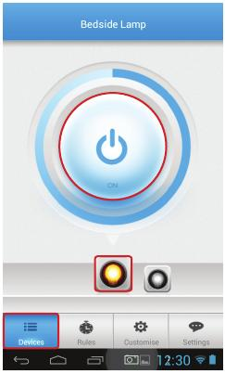
Product Operation
Switching On and Off
To control your wifi socket simply follow the below instructions.
1. Open the SmartPoint App, and select Devices from the main screen.
2. Select the device you wish to control, then press the power button to
toggle between on and off state.
Tip: The indicator light on the front of your Wifi Socket will be solid
Red when in OFF status, and solid blue when in ON status

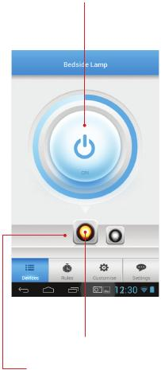
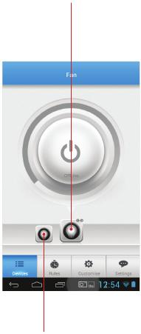
Check the Current Status of Your Appliance
1. Open the SmartPoint App, and select Devices from the main screen.
2. Select the device you wish to control, refer below.
Offine
On/Off/Offine status (unreachable)
for selected device status shown with
broken chain

On status shown with
coloured icon
Off status shown with
grey icon

All Wifi Sockets which have been
programmed with this iOS / Android phone are shown at the
bottom of the screen

Timers and Schedules
Your wifi socket can be used to manage your device power
using automatic timers and schedules.
Setting the Automatic Timer
1. Connect your iOS/Android Phone to the Wi-Fi network.
2. Open the SmartPoint App, and select Rules from the main screen.
3. Select Timing from the menu at the top of the screen, then select the
rule you wish to modify or create a new rule by pressing Add.
4. Repeat – Select the days you wish your rule to activate. For a single
time only rule, you should select single from the list.

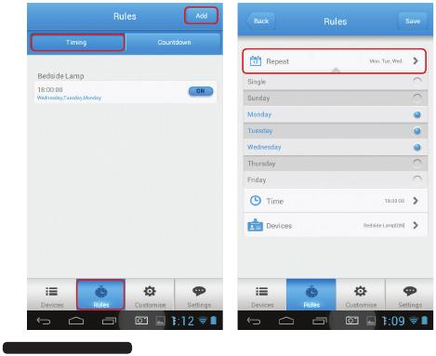

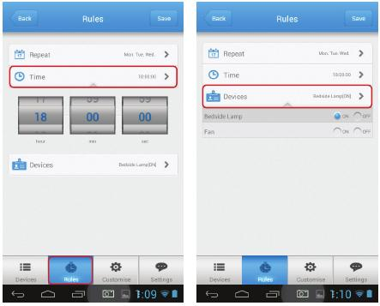

5.
6.
7.
Time – Select the time you wish the action to be performed.
Devices – Select the on/off status you wish for each of your connected
wifi sockets at this time.
Once you have finished making changes, click Save to return to the
Rules menu.
Tip: To return to the Rules menu without saving the timer,
select Back

Using the Countdown Timer
1. Connect your mobile to a Wi-Fi or 3G/4G network.
2. Open the SmartPoint App, and select Rules from the main screen.
3. Select Countdown from the menu at the top of the screen, then select
the wifi socket you wish to control.
4. You have the option to select a preset time period (A), or create your
own time period (B) using the hour : min : sec selector.
5. Choose if you would like the wifi socket to be in on status at the
end of the countdown, select “ON”. Select “OFF” if you wish
the wifi socket to be in off status at the end of the countdown.
Note: The timer can support 1 countdown task and 10 timers

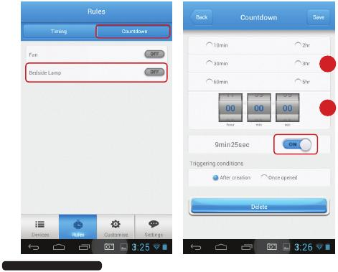
A

B

6.
7.
Set the triggering condition:
a. After creation – The countdown timer begins as soon as you press
save, and will operate once only.
b. Once opened – The countdown timer begins every time the wifi
socket is operated. For example, if you switch on, the countdown
timer will switch off after the time period has passed,
i.e. setting a maximum on time for the wifi socket.
Once you are finished making changes, select Save to return to the
Rules menu
Tip: To exit the countdown timer menu without saving your
changes, press Back.



Controlling your wifi socket from a Second iOS / Android Phone
Once you have set up a wifi socket a second iOS/Android phone
can discover it over your home Wi-Fi network and also control it remotely.

- Ensure your iOS / Android phone is connected to your home Wi-Fi network.
- Open the SmartPoint App on your iOS / Android phone.
- Click the Settings icon at the bottom of the screen, then select Smart Setup.
- Your wireless network name (SSID) is shown in the smart setup screen
below is an empty field to enter your Wi-Fi network password. Enter
your password into this box, then press Done.

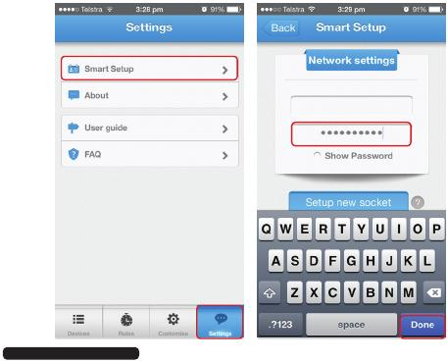

SSID

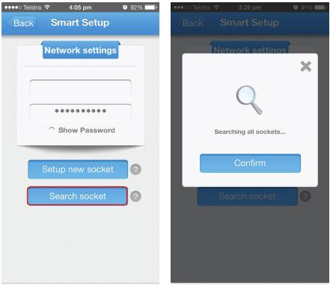

5.
Select the Search socket button on your iOS / Android phone.

The App will begin to search for the wifi socket currently connected to
your home Wi-Fi network.

SSID

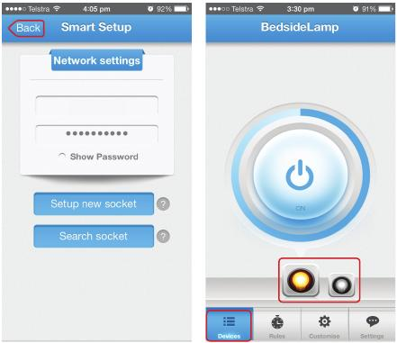

6.
Once searching is complete, press Back, then click Devices. You should
now see all the wifi sockets connected to your Wi-Fi network.

Note: If you have set the wifi socket to locked mode it will not be
discoverable by other devices. Refer to page 14 for further information.

SSID

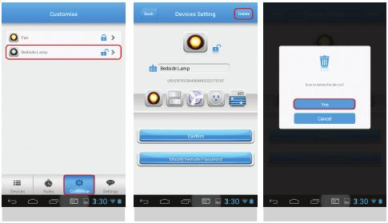
Deleting a Device from the SmartPoint App
1. Open the SmartPoint App on your iOS / Android Phone.
2. Click the Customise icon at the bottom of the screen, then select the
wifi socket you wish to delete.
3. Select Delete from the top right corner of the screen. Press OK to
confirm you wish to delete the wifi socket.
4. You will be returned to the Customise screen, when you can select
another wifi socket if you wish.

Frequently Asked Questions

Question | Answer
How can you tell if the Wifi Socket  Is successfully paired with  my router? | If you are successfully paired the light on the  Wifi socket will stay lit.
What if I change or update my  router? | You will need to reconfigure your Wifi socket to work with your new router, by following the steps on page 6.
From what distance can I control  the Wifi Socket? | You can control your Wi-Fi Socket from any location in the world, as long as your iOS / Android device can access the internet through  Wi-Fi or 4G/3G network.
Why has my Wifi Socket turned off  unexpectedly? | Your Wi-Fi network may have turned off. Please  check and restart your wireless router, then  power-on the Wifi socket.
What appliances are suitable to  use with the Wifi Socket? | The Wifi socket will work with any home appliance that currently plugs into a Smart point and draws under 2400W power.  The Wifi socket is best suited to appliances which do not contain internal on/off switching, or which can be switched to an always on state. For example, a traditional lamp would be well suited to the Wifi socket but a touch-lamp which resets to the off position when the power is cut, would  not be a good choice for the Wifi socket.

Question | Answer
Can I control multiple Wifi Socket? | Yes, you can add up to 100 Wifi socket to your home network.  Note: The number of devices that can be  connected to your home network depends on  your router / modem. Refer to manufacturer  instructions for more information.
Can others within my home  network control my Wifi Socket? | Yes, see page 21, “Controlling your Wi-Fi Smart  Point Plug from a second iOS / Android  Phone” in this product manual. Each Wifi Socket also has a lock function which  will prevent others on your network from seeing  it. This can be controlled from the Settings menu.
What can I use the countdown  function for? | This will leave appliances on for a time that  you set. It can be used as a timer to turn off  appliances you only want on for a period of time.  For example, set your phone charger to tur n  off after 3 hours to stop power draw after your  phone has charged.
Why is light on the front of my  Wifi Socket flashing red? | If the light is slowly flashing red, the device  cannot connect to your network. See steps on  page 6.  If the light is flashing quickly, the unit is in pairing  mode. See steps on page 8 to setup network  connections.
How do I reset the Wifi Socket? | Connect the Wifi Socket to a power source and hold down the power button for 5 seconds to reset the unit.

